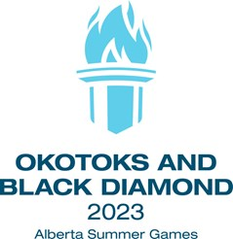
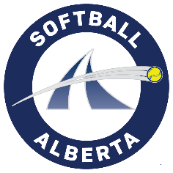
Zone 4

All eligible players are invited to attend a try-out camp for the selection of the Zone 4 team for the 2023 Alberta Summer Games.

Player Eligibility:
Players must meet the following requirements for the Alberta Summer Games:
- Age requirement – Under 15 prior to January 1, 2023 (born in 2008 or later). The minimum age is 13 as of July 23, 2023.

- Residence requirement – Each player MUST be a resident of the zone to compete for that zone.

- Category requirement – Players must be affiliated with Softball Alberta for the current softball season to a team at the U15B, C, or D or lower levels.

- All Players must participate in at least one zone camp (an $11.50 per camp tryout fee is applicable) to be eligible for selection.

Tryout #1
Date: Friday, April 28
Location: Stettler (exact TBA)
Time: 5:00 pm – 8:00 pm
Tryout #2
Date: Friday, May 5
Location: Stettler (exact TBA)
Time: 5:00 pm – 8:00 pm

Assessment of players will be based on any and all information available, including performance at camps, league games, playoff games, and Provincial Championships along with personal scouting by the coaches and information provided by club team coaches.
Note: If a player is unable to attend, but interested, please complete the registration process and email to be notified of the next camp. Email to: Kayla Myshaniuk (kmyshaniuk00@gmail.com).

TEAM
- The size of the final team shall be fourteen (14) players unless the zone has fewer than fourteen (14) players try out for the competition.
- Players may be removed from the athlete pool or from a Zone Team due to:
- Inability to perform due to injury, illness or for other medical reason as determined by a medical practitioner
- Violating team rules and/or Softball Alberta’s policies and procedures
- Exhibiting conduct that is detrimental to the image of the Alberta Summer Games program
- Breaching the Alberta Sport Code of Conduct
- Voluntarily withdrawing
- Fraudulently misrepresenting themselves
- Players selected to the final Zone Team will pay the following registration fees:
- $11.50 per tryout camp fee
- $80 individual Alberta Summer Games fee
- Up to $150 plus GST for the cost of uniform and attire (Includes uniform top, jacket, socks, hat and belt. Players will be responsible to get their own black pants.)
- Additional team costs for specialty items like T-Shirts, hoodies etc. is at the choice of the final chosen team.
Note: Equipment is the responsibility of the head coach, but each player is to provide their own cleats, helmets, bats, catcher’s equipment and water bottle.
Teams may look for their own sponsorships locally provided that they are not in conflict with Alberta Sport or Host Society sponsorships for the Alberta Summer Games.

