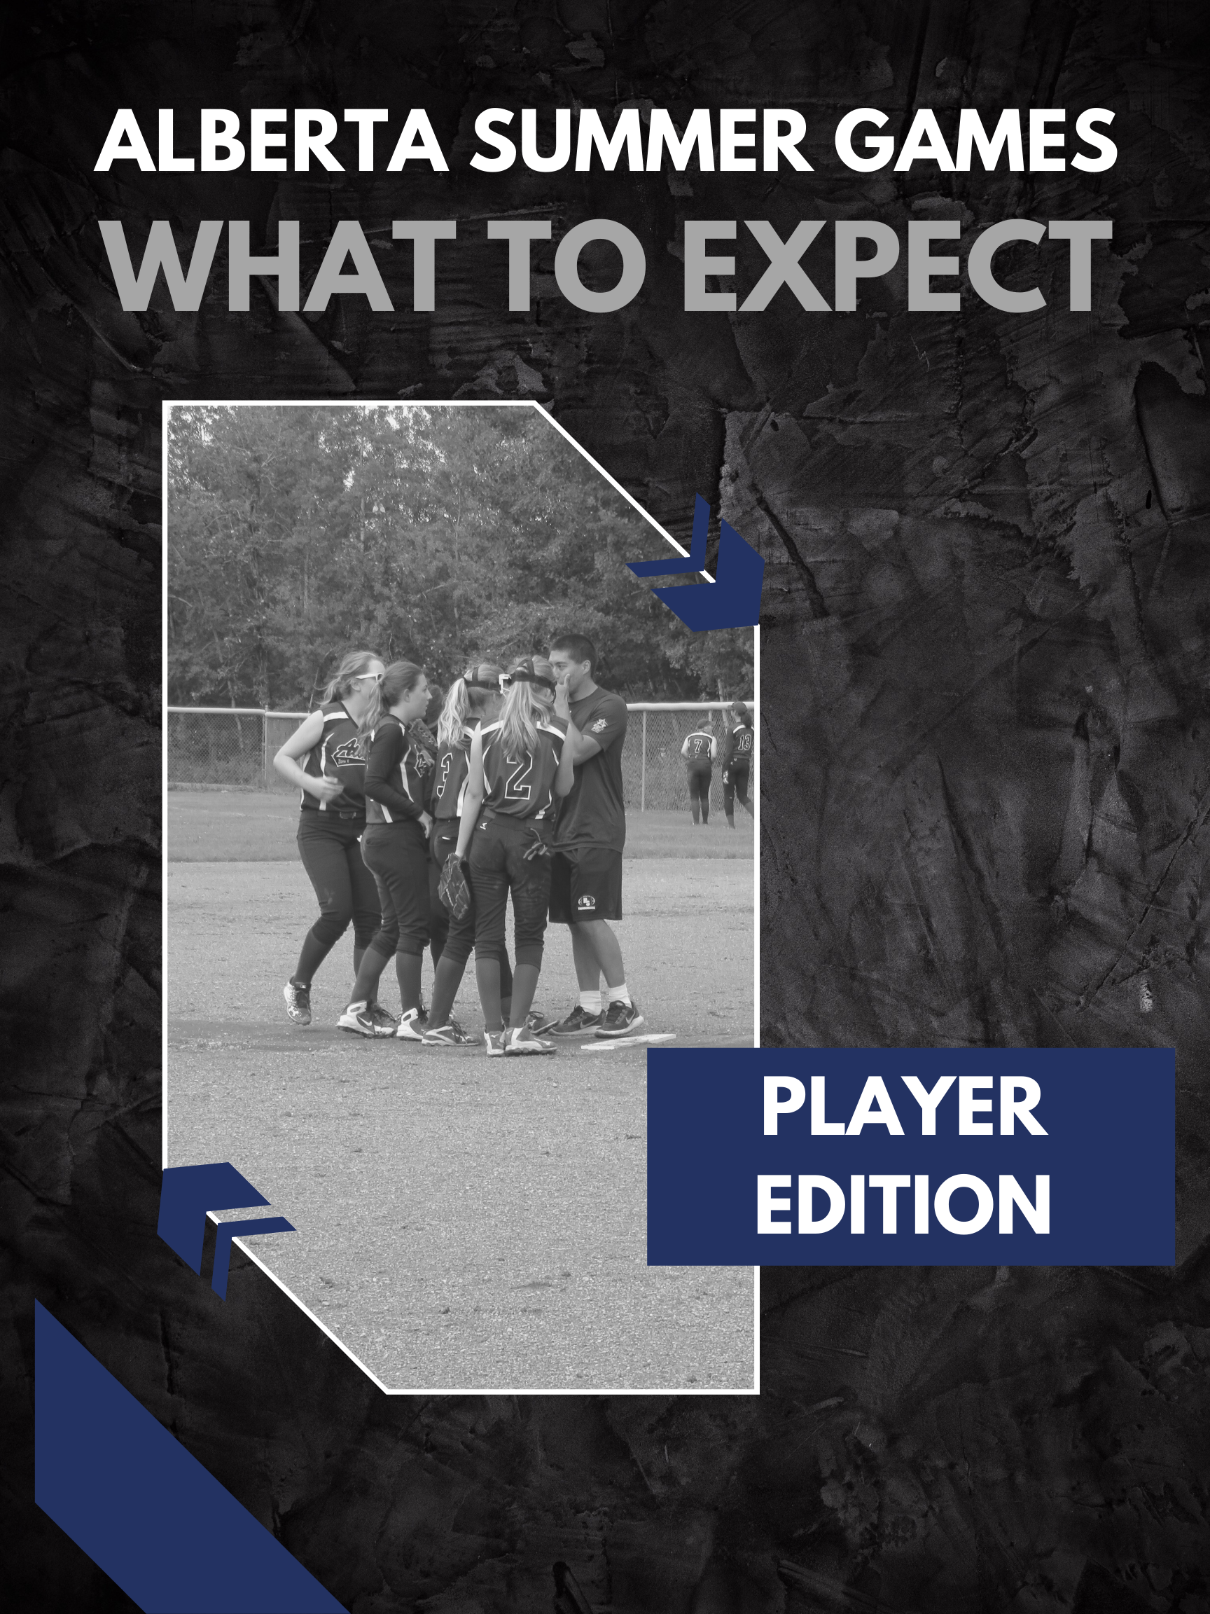

Alberta Summer Games
The Alberta Games provide many benefits to both the host community and to thousands of Albertans who participate at local, zone, and provincial levels. Alberta Games provide an opportunity to celebrate young athletes and provide them with a venue to compete and reach their athletic potential.
Alberta Games provides a competitive opportunity for provincial athletes at the ‘Train to Train’ level of CS4L to compete in a multi-sport Games.
Since the first-ever Alberta Winter Games were introduced in 1974, thousands of Alberta athletes have participated in communities across the province.
GOALS OF ALBERTA GAMES
- Motivate Albertans to achieve a higher level of physical fitness through more active participation in sport.
- Showcase the talents of Albertans in a wide range of sport and activities
- Provide host communities with a legacy of experienced volunteers and upgraded facilities
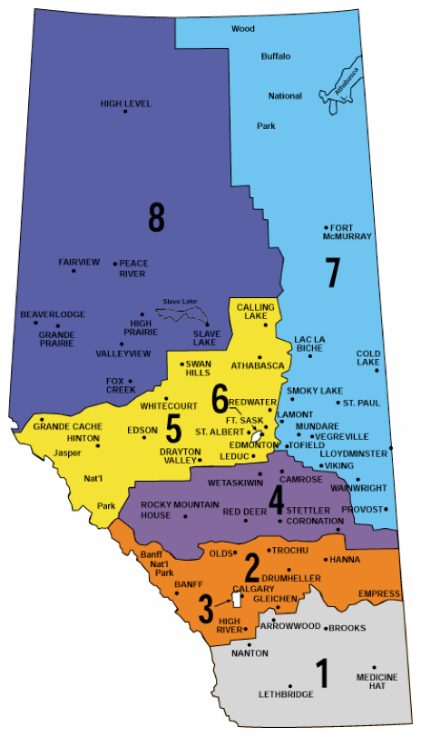 | Which Zone do I belong to?  Zone 1 - Sunny South (Grey)  Zone 2 - Big Country (Brown)  Zone 3 - Calgary (Red)  Zone 4 - Parkland (Orange)  Zone 5 - Black Gold/Yellowhead (Yellow)  Zone 6 - Edmonton (Green)  Zone 7 - North East (Navy Blue)  Zone 8 - Peace Country (Royal Blue)  How do I know which Zone I am in?  Alberta is divided into 8 Zones for the Alberta Games. Each Zone is assigned a color for identification during the Games.

AM I ELIGIBLE TO TRYOUT?
To be eligible for a Zone team, a player must be registered through an approved affiliation process for the current softball season to a team at the U15 B, C or D level and must confirm their residency and citizenship. Any female players who meet the affiliation requirements and are under 15 years of age prior to January 1, 2023 (born in 2008 or later) are eligible. The minimum player age be 13 as of July 23, 2023.
WHY IS THE ALBERTA SUMMER GAMES FOR U15 B GIRLS?
Softball Alberta would like to continue taking part in the Alberta Summer Games. Most Zones cannot field an ‘A’ caliber team and if we do not have at least four of the eight Zones represented with Zone teams, softball would be removed from the Games. The pool of U15 B players is much larger across the province and should result in all eight zones being represented.
HOW DOES THE TRYOUT PROCESS WORK?
- Tryout information will be posted to Softball Alberta’s website on the applicable Zone pages.
- Players must attend at least one tryout to be eligible for their Zone team. Each Zone team will be made up of 14 athletes. Each Zone Team is required to name an alternate.
- Each player must register through the designated registration process prior to tryouts.
- Each tryout will cost athletes $10 (plus a $1.50 RAMP fee for the first tryout payment), which will be collected during the online registration process.
- Tryouts may begin the fall of the year prior to the games and/or early spring of the year of the Games.
- The team must be finalized by June of the year of the Games.
I’VE MADE THE TEAM….. NOW WHAT?
Each Zone Team is limited to 4 practices before the Softball Alberta Provincial Championships & unlimited practices after the Provincial Championships.
UPON SELECTION TO THE ZONE TEAM, A PLAYER MUST:
- Sign the Alberta Sport Code of Conduct and register online by the registration date.
- Provide Softball Alberta with all the required contact information
- Participate in Team events, activities and meetings, directed by the Head Coach or their designate
- Abide by all rules, policies & procedures established by the Head Coach and/or Softball Alberta and/or Alberta Sport
- Each player is required to pay a fee ($150+ $80). The $150 covers the player’s uniform, jacket, socks and belt. The $80 fee is an Alberta Sport fee. It goes towards accommodations, transportation, Zone apparel and food while at the games.
A PLAYER MAY BE REMOVED FROM THE ATHLETE POOL OR FROM A ZONE TEAM DUE TO:
- Inability to perform due to injury, illness or for other medical reason as determined by a medical practitioner
- Violating team rules and/or Softball Alberta’s policies and procedures
- Exhibiting conduct that is detrimental to the image of the Alberta Summer Games program
- Breaching the Alberta Sport Code of Conduct
- Voluntarily withdrawing
- Fraudulently misrepresenting themselves

WHAT HAPPENS AT THE ALBERTA SUMMER GAMES?
Games participants (athletes, coaches and chaperones) stay in local schools, called an 'Athletes’ Village'. Male and female Athletes Villages are separate. All participants (athletes, coaches and chaperones) are required to stay in the Athlete Village for the 3 nights of the Games. This is part of the Code of Conduct signed by every participant and parent. Anyone who does not follow the Code of Conduct could be subject to sanctions from Alberta Sport.
Each Zone team is assigned 1 or 2 classrooms within each Village depending on the size of your team. Only accredited participants are allowed in the appropriate Villages. Food and drinks are not allowed in the housing rooms at the Athlete Villages. Mattresses will be provided but all participants must bring their own sleeping bag and pillow. There is an 11:00 pm curfew for all participants. Team officials may mandate their own curfew times prior to 11:00 pm.
On Sunday morning, all participants will check out of their Athletes’ Village and take all their luggage and belongings. This will be stored in a secure area until departure. Participants may also depart the Games via personal transportation.
Day One – Thursday
- Thursday is a travel and arrival day for Games participants
- Participants will arrive at the Host Community, get their accreditation at a Registration Centre and check-in at their Athletes Village. Participants will be bussed to supper before attending the Opening Ceremonies that evening.
Day Two, Three & Four – Friday, Saturday & Sunday
- The Zone Team will go to breakfast and then on to their competition using the Host’s internal transportation (depending on your sport’s schedule)
- Breakfast & supper will be served at a main Food Centre during the Games
- Lunch plans on Friday and Saturday will be discussed during softball’s Sport Conference Call
- Check softball’s schedule to determine when the Zone Team will be able to visit the Food Centre for supper on Friday and Saturday.
- The Host Community holds an Athlete Social Event and Coaches/Officials Reception on Saturday evening from 7:00-10:00 pm
- Most sports will hold medal matches/finals on Sunday morning following check-out from the Athlete Villages. When sports are completed on Sunday, participants will gather (usually at the Food Centre) for the Alberta Games Closing Awards presentation in the early afternoon.
- Participants will depart following Closing Awards.

